Ilan Weinschelbaum
Assignment 8

Exercise 2.
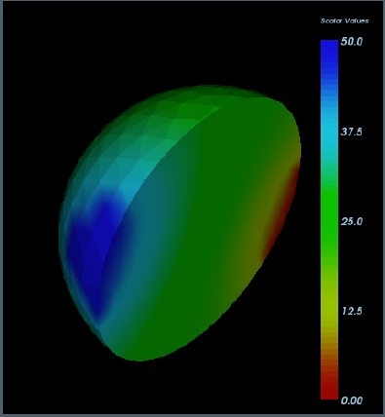
Exercise 3.
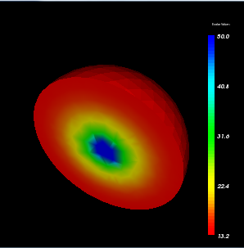
Tf = 10, Original Convective Coeff matrix
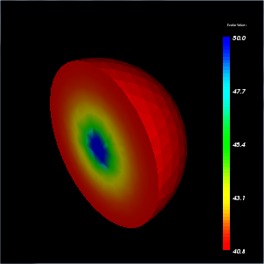
Tf = 40, Original Convective Coeff
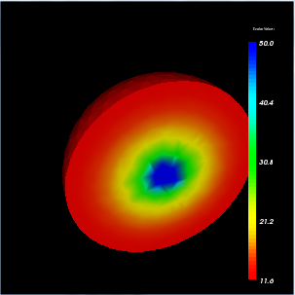
Tf = 10, doubled Convection Coeff Matrix
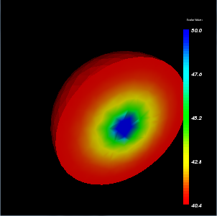
Tf = 40, doubled Convection Coeff matrix
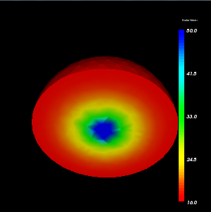
Tf = 10, halved Convection Coeff Matrix
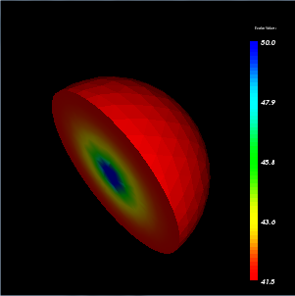
Tf = 40, halved Convection Coeff Matrix

